Superstore Sales Data
Data Import, Power Query & Data Preparation
Week 1 – Documentation Report
Prepared using Power BI Desktop – Power Query Editor

Name: Deepika J
Roll.no: E25DAOO8
Dept: B.Sc. DS and AI

Objective
The aim of this exercise is to prepare retail sales information for analysis by examining customer orders, product categories, regional results, and profitability. Before developing a business intelligence dashboard, the raw Superstore dataset needs to be imported, cleaned, transformed, and organized in Power BI through the Power Query Editor.
Tasks Covered
- Import the Superstore CSV dataset into the Power Query Editor.
- Promote the first row as headers and assign suitable data types to the columns.
- Make text values consistent across categorical fields, such as converting Ship Mode to uppercase.
- Create a duplicate of the Order Date field and arrange the columns in the required order.
- Apply regional locale settings while converting Date/Time and Date values.
- Extract the Day value from Order Date to create an additional date-related attribute.

Step 1: Reviewing Data Types and Exploring Transformation Options
Once the Superstore dataset was brought into Power Query Editor, the headers were promoted and the column data types were checked and adjusted. The Applied Steps section records the main sequence, including Source, Promoted Headers, and Changed Type.
The formula bar shows the data type conversion applied to important fields: Row ID is treated as a whole number (Int64.Type), Order ID is stored as text, and Order Date is recognized as a date.
The Transform options available for the "Ship Mode" column include lowercase, UPPERCASE, Capitalize Each Word, Trim, Clean, Length, JSON, and XML. These options support consistent formatting of categorical text data.
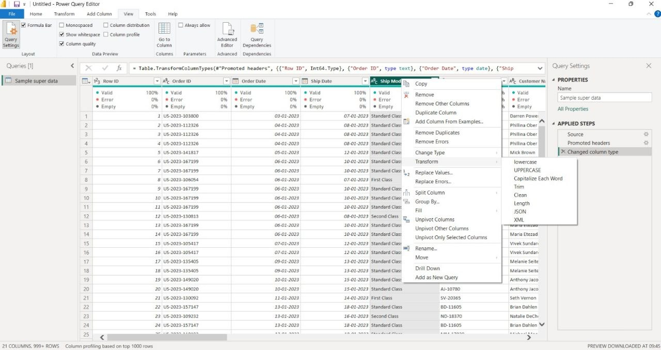
Step 2: Copying and Reordering the Order Date Column
The Ship Mode values were standardized by converting the text to UPPERCASE. The Order Date field was then duplicated so that the original date information remained unchanged while a separate "Order Date - Copy" column could be used for extracting date components.
At this stage, the Applied Steps pane records transformations such as Changed Type, Changed Type with Locale, Changed Type with Locale1, Duplicated Column, and Reordered Columns.
The Transform menu for the duplicated date column provides several date-related choices, including Year, Quarter, Month, Week, and Day. The Day options include Day, Day of Week, Day of Year, Start of Day, End of Day, and Name of Day.
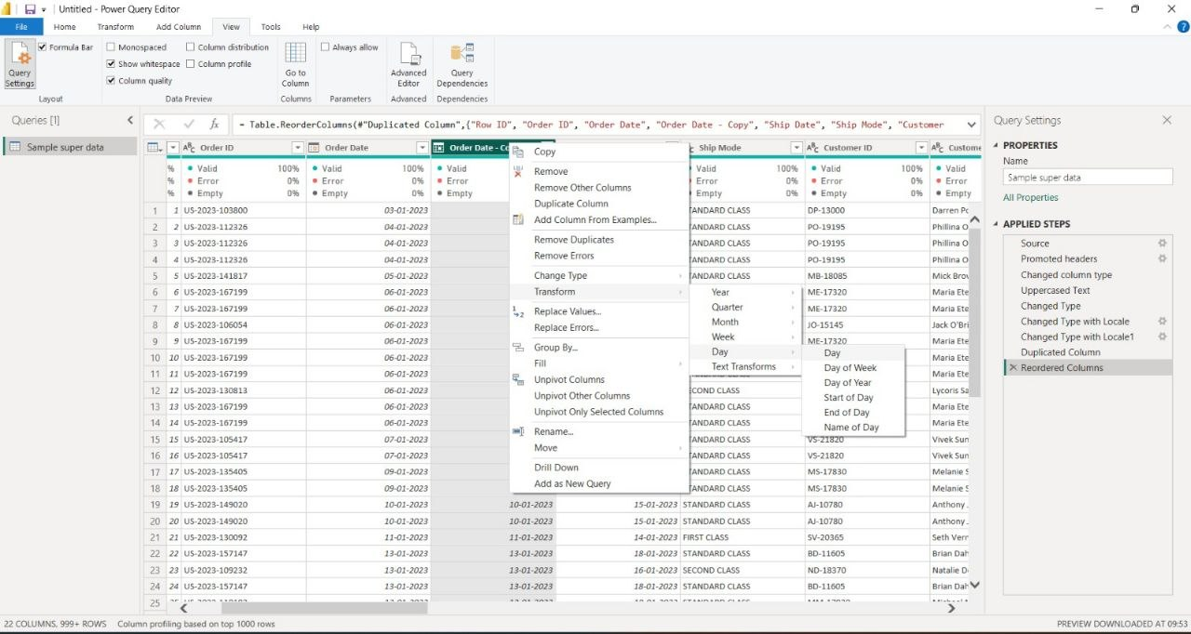
Step 3: Applying Change Type with Locale (Date/Time – English India)
The Change Type with Locale feature was used to clearly specify how the Order Date values should be interpreted. This is important because date formats can differ between regions.
For this conversion, the Data Type was selected as Date/Time and the locale was set to English (India). Example source values such as “29 March 2016 14:45” illustrate the day-month-year format used in the dataset.
Using the correct locale helps Power Query read the date and time values accurately and prepares the field for reliable date-based transformations and calculations.
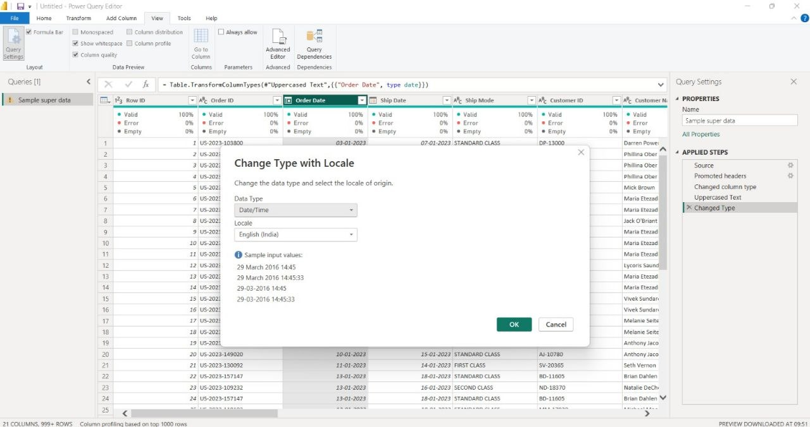
Step 4: Deriving the Day Value from Order Date
After placing the Order Date - Copy column beside the original Order Date column, the Date.Day function was applied through Table.TransformColumns. This extracts only the day number from each date and converts the result into a whole-number type (Int64.Type).
The Applied Steps section confirms the transformation sequence, including Changed Type with Locale, Changed Type with Locale1, Duplicated Column, Reordered Columns, and Extracted Day.
The resulting column contains numeric day values such as 3, 4, 5, and 6 for the corresponding orders. This creates a useful custom date attribute for future analysis.
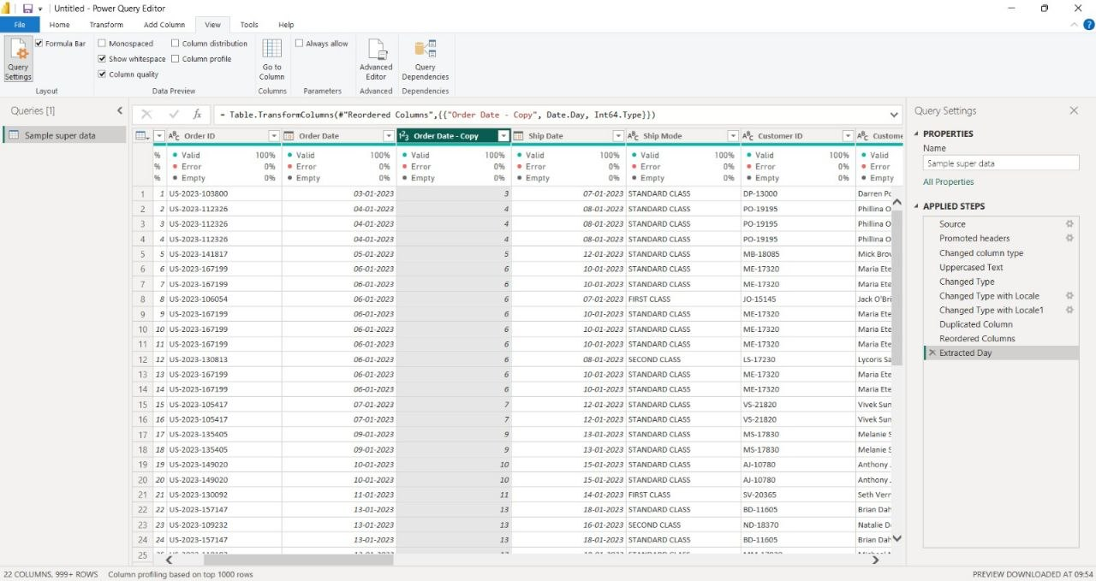
Step 5: Applying Change Type with Locale (Date – English United States)
In this stage, the Order Date field was converted to a Date-only value using the English (United States) locale.
Examples such as “3/29/2016” and “Tuesday, March 29, 2016” show that the same date can appear in different formats depending on the regional setting.
This step demonstrates that locale selection influences both the way Power Query interprets text as a date and the way the resulting date is displayed.
Conclusion
During this Week 1 exercise, the Superstore sales dataset was successfully imported into Power BI and prepared through the Power Query Editor. The headers were promoted, column types were reviewed and corrected, and text fields such as Ship Mode were standardized for consistency.
The Order Date field was duplicated and repositioned so that the original information could be retained while a separate Day attribute was created using the Date.Day function.
The Change Type with Locale option was also demonstrated using two regional settings: English (India) for Date/Time conversion and English (United States) for Date conversion. This showed how regional settings can affect the interpretation and presentation of date values.
Overall, the exercise covers essential data-preparation activities such as checking fields, correcting data types, standardizing text, and deriving useful date attributes such as Day, with the same approach extendable to Year, Quarter, Month, and Day of Week. The cleaned table is now suitable for the next stage of the project, including relationships, DAX measures, and the interactive Superstore Sales Dashboard.

Week 2 – Data Visualization & Dashboard
Superstore Sales Data
Prepared using Power BI Desktop

Objective
The objective of Week 2 was to use the cleaned Superstore dataset in Power BI to create a simple interactive sales dashboard. The dashboard focuses on key sales and profit values and provides category, regional, and sub-category views.

Tasks Covered
- Create a Total Sales KPI card.
- Create a Total Profit KPI card.
- Create a Sales by Category chart.
- Create a Sales by Region chart.
- Create a Sales by Sub-Category chart.
- Create a Profit by Category chart.

Step 1: Creating the Total Sales Card
A Card visual was selected in Power BI. The Sales field was added to the visual and summarized as Sum of Sales. This card displays the overall sales value from the Superstore dataset.

Step 2: Creating the Total Profit Card
Another Card visual was created using the Profit field. The field was summarized as Sum of Profit to show the overall profit value in the dashboard.

Step 3: Creating Sales by Category
A Clustered Column Chart was created to compare sales across product categories. Category was placed on the X-axis and Sales was placed on the Y-axis.

Step 4: Creating Sales by Region
A Stacked Bar Chart was created to compare sales across regions. Region was placed on the Y-axis and Sales was placed on the X-axis.

Step 5: Creating Sales by Sub-Category
A Stacked Column Chart was created to display sales for different sub-categories. Sub-Category was placed on the X-axis and Sales was placed on the Y-axis.

Step 6: Creating Profit by Category
A Clustered Column Chart was created to compare profit across product categories. Category was placed on the X-axis and Profit was placed on the Y-axis.

Power BI Screenshot
The available Power BI report-canvas screenshot is included below as supporting evidence of the dashboard-building stage.
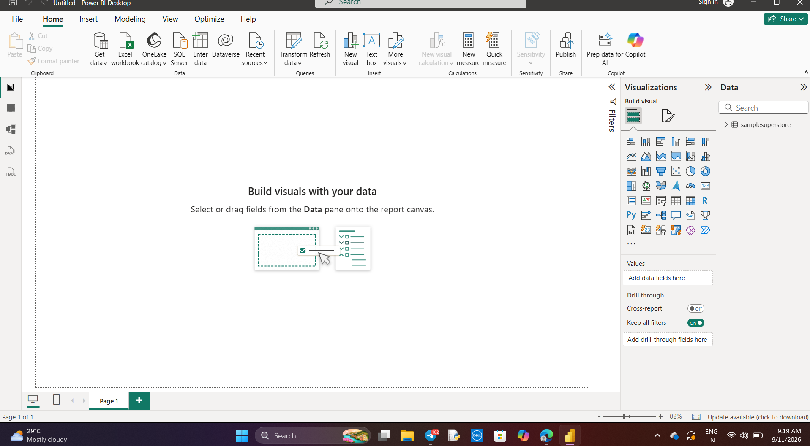

Dashboard Summary
The Week 2 dashboard brings together KPI cards and charts to provide a simple view of Superstore sales and profit. The visuals allow the data to be compared by category, region, and sub-category.

THE FINAL OUTPUT

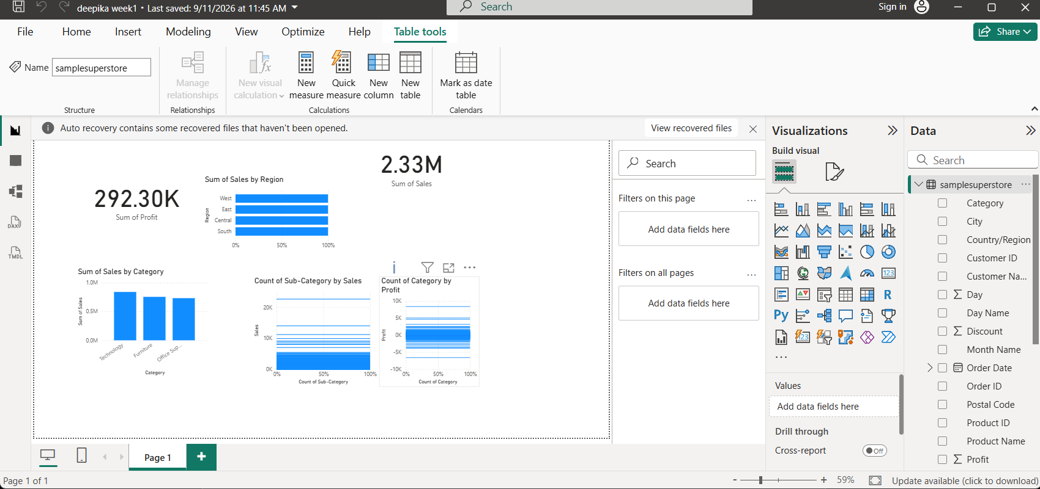

Conclusion
During Week 2, the cleaned Superstore dataset was used to build a basic Power BI sales dashboard. Total Sales and Total Profit were presented using KPI cards, while category, regional, and sub-category performance was displayed through charts. The completed visuals provide a clear summary of the sales and profit information and form the dashboard stage of the project.

